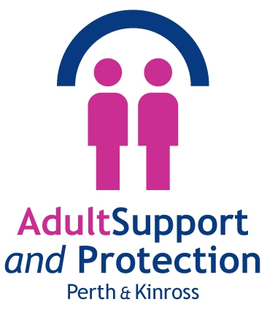

ASP Annual Report
2020 - 2021

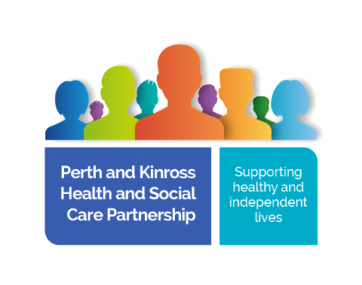



Contents
Page
- Introduction by the Chair of the Adult Protection Committee 3
- ASP Pictorial Summary 2020 - 2021 6
- Context 7
  - Perth & Kinross 7
  - Vision & Purpose 8
  - National Context 8
- Statutory Requirements 9
4.1 AP work seen as a priority 9
4.2 Employee health & wellbeing seen as a priority 9
4.3 Public Protection seen as a priority 10
4.4 The greater use of ASP Telephone inquiry as a means to safeguard 10
4.5 Sustaining our Tayside collaboration of Independent chairs 10
and Lead officers
4.6 Adult Protection Committee (APC) 11
- Analysis of Harm 11
5.1 Vulnerable Persons Reports (VPRs) and Adult Protection (AP) 11
Concern Referrals
5.2 VPR and AP Concern – analysis 13
5.3 Data relating to Adult Support and Protection (ASP) Cases 14
- Activity and Service Improvements 27
6.1 The introduction and implementation of Initial Referral Discussion 27
6.2 Qualitative audits 28
6.3 Feedback from Organisations 28
6.4 NHS Tayside AP Team Annual Report 2020 29
6.5 Public Protection (strategic) Group and Public Protection 29
Workforce Development
6.6 Public Protection (Practitioner) Group 29
6.7 Enhanced Care Home team 30
6.8 Serious Case Review (SCR) – Mr A 30
6.9 Initial Case Review (ICR) – Mrs C 30
6.10 Capacity Assessments 30
- Training, learning and Development 31
7.1 Staff Learning and development 31
  - Council Officer training 31
  - Safeguarding those in crisis, suicide prevention, community 31
engagement and lessons learned for ASP in 2021/22
  - Reducing the prevalence of suicide, self-harm, distress, and common 32
Mental health problems
  - Trauma Informed Practise 33
  - NHS E-learning Adult Support and Protection LearnPro Module 33
  - ASP Matters 33
  - Looking forward 34
- Engagement, Involvement and Communication 34
8.1 Feedback from service users and Carers 35
8.2 Communication and public awareness 35
8.3 Sustaining close safeguarding relationships with wider organisations 36
- Challenges and areas for improvement 36
- Covid-19 37

Introduction by the Chair of the Adult Protection Committee
I am pleased to present the Annual Report on the work of the Adult Protection Committee in Perth and Kinross from April 2020 to March 2021 and is in addition to the Biennial report which is a legal requirement to produce for the Scottish Government and which is due again in 2022.
This report gives particular focus to the impact of the COVID-19 pandemic and how it has affected adults at risk, how performance has been maintained and how services and agencies have successfully adapted. The report also confirms that the APC continues to focus on learning and improvement and has prepared a programme of improvement work for 2021 and beyond.
Whilst the Covid-19 pandemic was emerging during the last period of the previous Annual Report, there is no doubt, like all parts of society, Adult Support and Protection has been seriously affected by the pandemic over the last 18 months. For example, national and local research and experience has highlighted greater social isolation, shielding, and more limited and restricted opportunity for community support have all placed additional pressures on the most vulnerable and has resulted in increases in mental health issues, domestic violence, and pressures in care homes. To respond to these challenges, services too have had to significantly adapt including much more use of home/remote working, supported by digital technology, more close monitoring of the availability of key staff in adult protection and changes to working rotas and patterns to support areas under most pressure (e.g. care home, out of hours services). The Covid-19 crisis has required a collaborative approach across all key agencies and accelerated the progress that was already progressing in relation to a public protection approach in Perth and Kinross. Over the year this has developed into a formal partnership under the leadership of the Chief Social Work Officer and working together has been particularly useful in the development of more comprehensive data to inform key decision making and a common risk management approach across the public protection areas. In particular within Adult Support and Protection, enhanced data analysis has identified that despite a rising demand in Adult Protection work, performance in response to demand has also improved.
Initially during the pandemic both nationally and locally some of the plans for self-evaluation and improvement work had to be slowed but this has now resumed. For example, the National Improvement Programme, including scrutiny, is again fully operational and locally too, audit and self-evaluation around some of our key processes and leadership is ongoing. An important part of improvement work is learning from case reviews and in Perth and Kinross, as nationally, we have seen an increase in cases considered for Initial and Significant Review, although numbers remain very small.
Whilst the Annual Report is about reviewing and reflecting on progress over the last year it is also importantly about planning for the future and this year the report includes an Improvement plan outlining key priorities for the coming year including, further understanding of the impact of the pandemic on Adult Protection work; working across public protection to jointly tackle issues including young people in transition; violence against women; financial harm and mental health. We also need to continually review key processes such as how we gather and use chronologies; use initial referral discussions and importantly how we involve service users and their families in service delivery and planning.
Lastly, I would like to acknowledge in the last year Mary Notman has retired after a very lengthy period as Adult Protection Coordinator in Perth and Kinross. Mary was one of a small band nationally who advocated tirelessly for greater protection for vulnerable adults in legislation, policy, and practice. Mary’s enthusiasm and compassion will be sorely missed but I am delighted Iain Wilkie has taken over the role and management and administrative support has been enhanced


Independent Chair
Perth & Kinross Adult Protection Committee

Background
The Adult Support and Protection Act (Scotland) 2007 aims to protect adults who are unable to safeguard their own interests and are at risk of harm because they are affected by disability, mental disorder, illness or physical or mental infirmity. The Act places duties on councils and other organisations to investigate and, where necessary, act to reduce the harm or risk of harm.
Section 46 of the Act requires the Convenors of Adult Protection Committees (APC) to produce a biennial report analysing, reviewing, and commenting on APC functions and activities in the preceding two years. However, it is our position that an annual standard and quality report is also produced to give an overview of the key activities and work of the APC to safeguard adults from harm. This report identifies achievements, key strengths, the impact of the COVID-19 pandemic and areas for further improvement. It also sets out the APC’s programme of improvement work for 2020 and beyond.
The format of this report has changed from previous annual reports submitted by the APC. In this reporting year, the Scottish Government has been working in collaboration with IRISS (https://www.iriss.org.uk/) to develop a consistent biennial reporting template for all APCs to use to help focus on key areas of AP activity and give the opportunity for committees to compare and contrast AP activity nationally.

Reporting
The purpose of the annual report is to give an overview and some analysis of the Adult Protection (AP) activity across Perth & Kinross between 1 April 2020 and 31 March 2021.
This report seeks to report and analyse the effectiveness of ASP activity over this last reporting year, identify the achievements and areas for improvement.

- ASP Summary 2020 - 2021
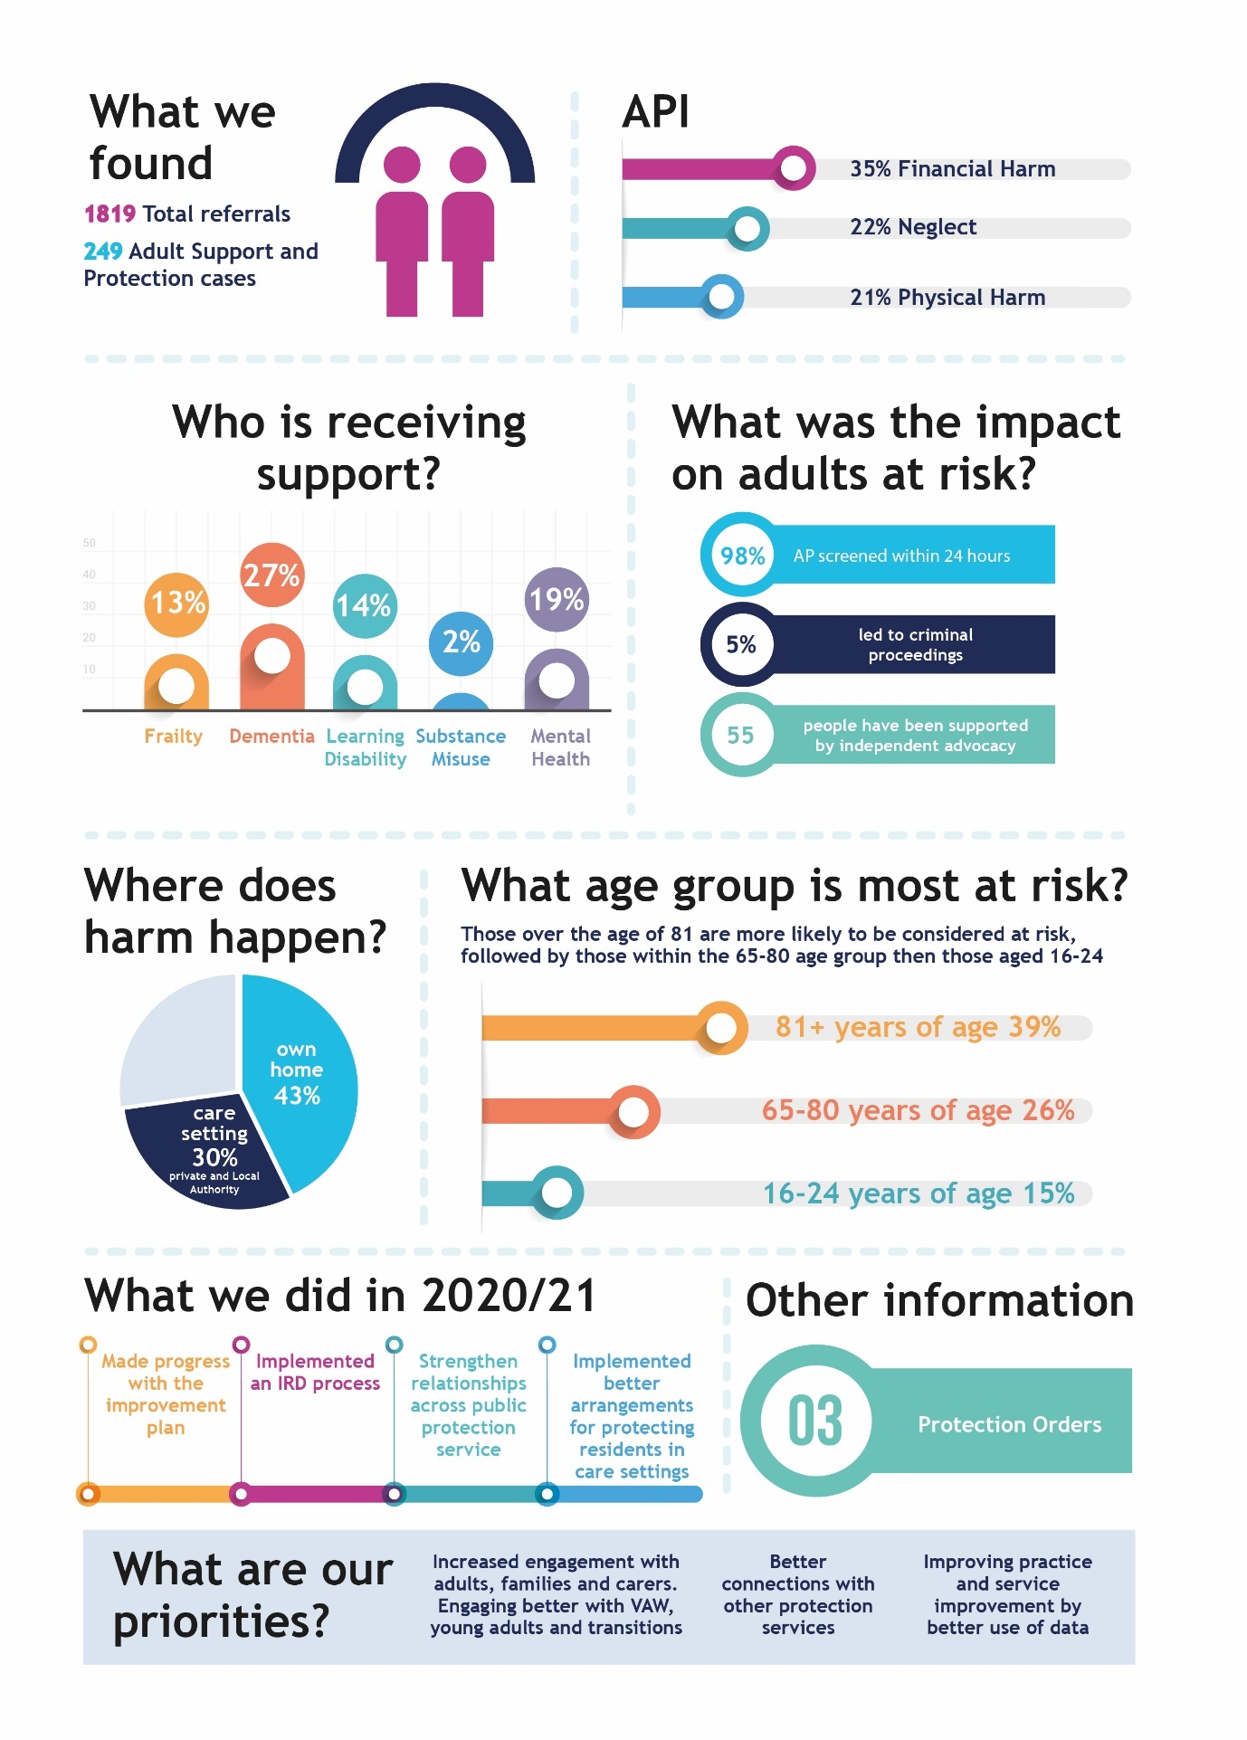

- Local and National context to Adult Support & Protection

  - Perth & Kinross
Perth and Kinross cover an area of 5,286 square kilometres and is the fifth largest area by land mass in Scotland. As of 2019, it had a population of 151,950; which has grown 12.9% over the past decade, compared to 7.6% for the whole of Scotland: It is the 8th fastest growing population in Scotland. The number of people resident in Perth & Kinross who are over 65 years old accounts for 23.6% of the population, compared to 17% for the whole of Scotland. The age group 75 and over has increased by 50.1% over the past decade, whilst its younger age cohort (25-44 years) decreased by 8.6%.
The older age profile is reflected in that the average age of the population in Perth and Kinross is 43 years, slightly higher than the national average age of 40 years.
The population of Perth and Kinross is made up of 74,729 males and 77,221 females.
- There are 24,421 (16.1% of population) children (aged 15 and under)
- There are 91,695 (60.3%) people of working age (aged 16-64)
- There are 35,834 (23.6%) older people (aged 65 and over)
The geographical distribution of the population across urban, rural, and remote areas poses challenges for the planning and delivery of services.
In Perth and Kinross, there are five community planning partnerships:
- Perth City
- Kinrosshire, Almond & Earn
- Strathearn
- Highland and Strathtay
- Strathmore
These localities each have a local action partnership made up of elected members, communities, and public services.
Through the local action partnerships, the community planning partnership identifies their particular needs and challenges. Perth & Kinross council has 40 councillors in 12 electoral wards.
NHS Tayside is responsible for commissioning health care services for residents across Tayside and had a combined population of 416,550 based on mid-year 2020 population estimates published by National Records of Scotland.

  - ASP Vision & Purpose
People have the right to live as independently as possible in a safe environment, free from harm, to have their wishes and feelings considered and to have the minimal amount of intervention into their personal lives.
To support and protect adults who may be at risk of harm or neglect and who may not be able to protect themselves.
In this last year, we have been actively promoting and testing the awareness of ASP vision and purpose with practitioners and the extent to which the ASP vision and practice is embedded in practice.
  - ASP National Context
Adult Support and Protection in Perth & Kinross is set within the wider policy in Scotland and the National Policy Forum.
https://www2.gov.scot/Topics/Health/Support-Social-Care/Adult-Support-Protection
The National ASP Strategic Forum
The National Forum provides a strategic and cross sectoral view of what is needed to improve the delivery of Adult Support and Protection across Scotland. The Forum will assist Scottish Government and delivery partners in identifying the workstreams required to improve the assurance and operation of Adult Support and Protection and its interface with existing and developing legislative and policy areas.
The Scottish Government also supports the role of the National Adult Protection Coordinator – this role involves making connections to build stronger local networks and to improve the co-ordination, development, and dissemination of best practice, as well as promoting joint working between Adult Protection Committees.
The National Improvement Plan has identified 6 main areas:
- Assurance and Inspection
- Governance and Leadership
- Data and outcomes
- Policy
- Practice Improvement
- Prevention

- Statutory Requirements
The following is an overview of the pressures, developments, complexities, and challenges in delivering AP activity within this reporting year and the AP governance arrangements that oversees this work.

  - AP work seen as a priority
As will be discussed throughout this annual report, the impact of Covid has had a significant impact in how all services have been delivered since 1 April 2020. Throughout this reporting year, it has been seen as a service priority that Perth & Kinross had sufficient and available Council Officers to carry out AP work. Much of this was set against the backdrop of not being clear about the actual or potential pressure or impact the Covid pandemic had or had the potential to have on AP activity. In the early to mid-phase of Covid, data on council officer availability and data on ongoing AP work was reported to senior governance groups on a daily basis to give the assurances that P&K was able to meet the demands of all AP activity. Throughout this reporting year, there is no evidence that Perth & Kinross was unable to fulfil its statutory role in delivering AP work. However, evidence does show from within our data that despite the pressures, complexities, and challenges practitioners faced to fulfil statutory ASP responsibilities, improvements have been made in a number of AP areas. These include improvements in screening the increase in AP concerns within a 24-hour period and improvements in terms of inquiries and investigations completed within regulated timelines.
In the early phase of the pandemic, social workers moved into a more flexible 7-day working pattern to support any influx of concerns or referrals as a direct or indirect consequence of Covid. This arrangement also supported our existing out of hours social work service. However, after close monitoring and analysis of the AP concerns received, this arrangement stood down after a 2-month period and social workers and Council officers returned to normal working patterns.
Our data shows that there has been no single spike or a series of spikes in AP concerns received across the range of all AP activity since 1 April 2020, despite the impact of Covid, and this seems to be a trend and theme experienced across nationally. However, the data on AP concerns received throughout this reporting year does show that there has been a gradual incremental increase in the numbers AP concerns received. Some analysis will be given to this later within this report.
The number of Large-Scale Investigations (LSIs) concluded in this reporting year has fallen, and whilst his report gives greater analysis to the reasons for this elsewhere, it is considered that the supporting role of the care home oversight group has directly influenced this reduction.
In summary, despite the challenges faced by services and practitioners in this last reporting year, analysis of AP work has identified that:
- Partnership working is stronger
- Services have managed a significant increase in AP work in a number of areas
- Evidenced supports that in this last year, we have stepped up and strengthened our connections with the care home sector and the support given to it.

  - Employee health & wellbeing seen as a priority
In this last reporting year, whilst practitioners and council officers faced increased pressures as a direct and indirect consequence of safeguarding practices throughout a pandemic, greater emphasis has been placed on the professional and personal impact of the increased pressures on the health and wellbeing of those trying to work within it. A dedicated P&K wellbeing ‘champion’ has been identified and commitment given by Perth & Kinross Council, Health and within the HSCP to supporting a staff group manage the physical and emotional impact of practicing within a more pressured and complex working arena.
  - Public Protection seen as a priority
Throughout this reporting year, Perth & Kinross applied a greater focus on the wider public protection agenda. The role, the leadership, scrutiny and the governance of the Protecting People’s Coordinators Group, the Protecting People Workforce Development Group, the Protecting People Practitioners Group were all established in this reporting year. All of these groups were all established as a reaction to Covid and as a means to forge and strengthen relationships across all safeguarding agendas. More will be discussed about the impact of these groups later within this report.
  - The greater use of ASP Telephone inquiry as a means to safeguard
As a consequence of the restrictions placed upon society and the need to socially distance, greater emphasis was placed upon the use of telephone AP inquiries. Within Perth & Kinross, the use of telephone Inquiry’s existed prior to this reporting year. However, our data supports that in previous reporting years, the use of a telephone assessment was rarely used.
Within this reporting year, 51 telephone AP inquiries were concluded. This relates to 18% of all AS inquiry’s carried out between 1 April 2020 and 31 March 2021. Data for the previous reporting year suggests that only 2.5% of all AP inquiries were completed by telephone contact only.
Research carried out supports that virtual assessment by use of digital technological platforms such as Zoom, Skype, Microsoft Teams and telephones in AP work has the potential to expose weakness in the systems and structures that support safeguarding adults. Whilst there has been greater use of MS teams to the advantage of the service and it has allowed us to continue to deliver ASP work and other services throughout the covid period, we are clear that assessments as far as possible are better concluded face to face. Since March 2020, some creative and determined examples exist of Council Officers navigating their way around layers of restrictions and challenges in sustaining social distancing to carry out face to face AP assessments. However, our data also supports that despite these challenges and complexities of working within social distancing protocols, practitioners continued to find safe ways of carrying out face to face ways of interviewing and assessing adults where it was considered necessary.
  - Sustaining our Tayside collaboration of Independent Chairs and Lead officers
Despite the challenges in meeting face to face, the Independent Chairs, Lead Officers, Police Scotland, and NHS Tayside have continued to meet regularly in Tayside to coordinate work that provides consistency for regional partners and identifies common areas of ASP work. This has been done virtually via MS teams.
Work ongoing includes:
- A short life multi-agency working group to scope out the delivery of a Tayside wide ‘Inter-agency Referral Discussion’ (IRD) process.
- A working group across adult and child protection to provide an analysis adverse events, Initial case Reviews (ICRs) and Serious case Reviews (SCRs) competed across Tayside to look for overlap, commonality, and subsequent shared learning opportunities. This seeks to replicate a similar evaluation of ICRs, and SCRs commissioned by colleagues from within the Tayside Child Protection Committee.
- The development of a shared protocol for the implementation of learning reviews.
- The collection of a consistent data set

  - Adult Protection Committee (APC)
The Adult Protection Committee (APC) has continued to meet quarterly in this last reporting year. However, given the restrictions placed upon us all, these have met virtually via MS Teams. The APC continues to have wide representation to give a more diverse range of agencies and to reflect the broader public protection agenda and the views of the public.
Annually the APC compares national data with local data and investigates any differences. In this reporting year, particular attention has understandably been given to:
    - the impact of Covid and the correlation with AP concerns
    - Reviewing our conversion rate from ASP investigation to Adult Protection Case Conference.
    - Understanding the impact of Covid within our care home sector
The APC continues to report regularly to the Public Protection Group (PPG) Chief Officer Group (COG), the Integration Joint Board (IJB) and the Community Planning Partnership. This annual performance report for 2020/21, the AP contribution to the PKC Annual Performance Report and Chief Social Work Officer report will be presented to IJB and the equivalent Boards in Police and NHS Tayside. Within these contributions, focus will remain on progress relating to the various AP activity, and any subsequent AP related improvement plans.
- Analysis of harm
Evaluation: We are committed to the improvement of multi-agency data that will identify areas for improvement to inform practice
The following gives an overview and some analysis of the AP activity throughout 2020/21
  - Vulnerable Persons Reports (VPRs) and Adult Protection (AP) Concern Referrals
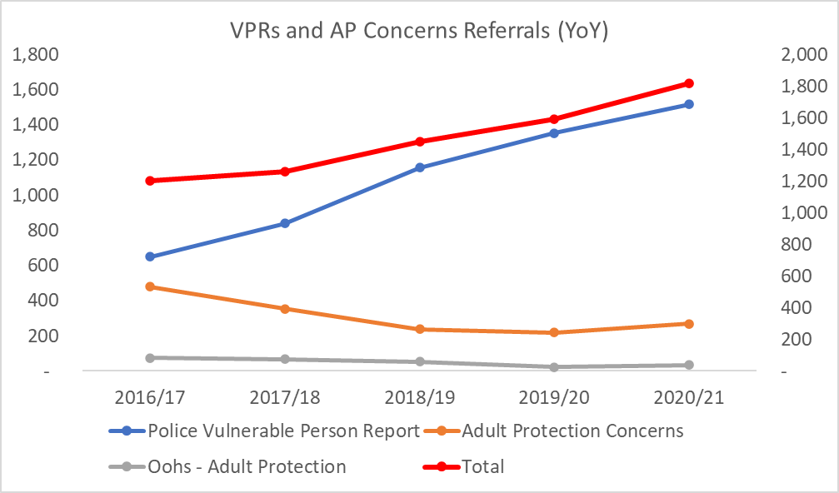

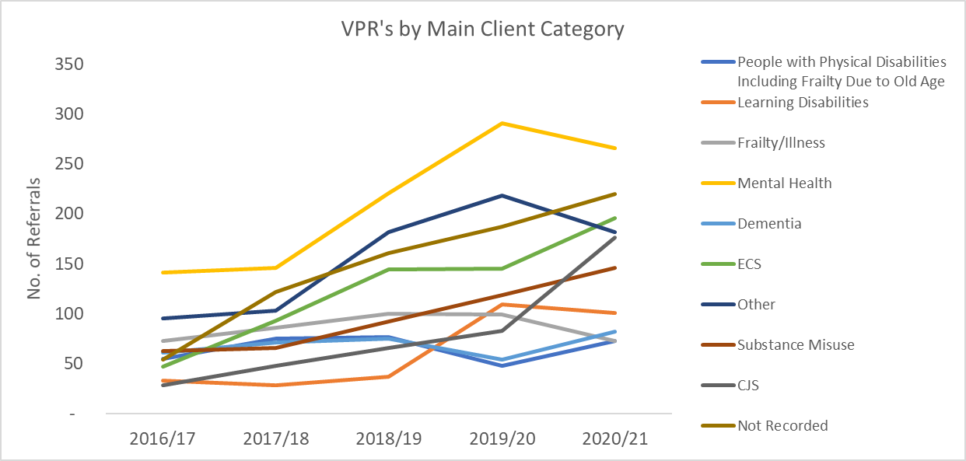
Table 1.10

Total number of referrals screened within 24 hours
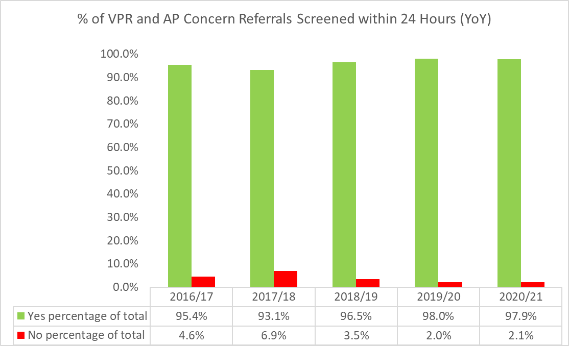

Outcomes of Referrals (VPR and AP Concerns)
VPR Outcomes

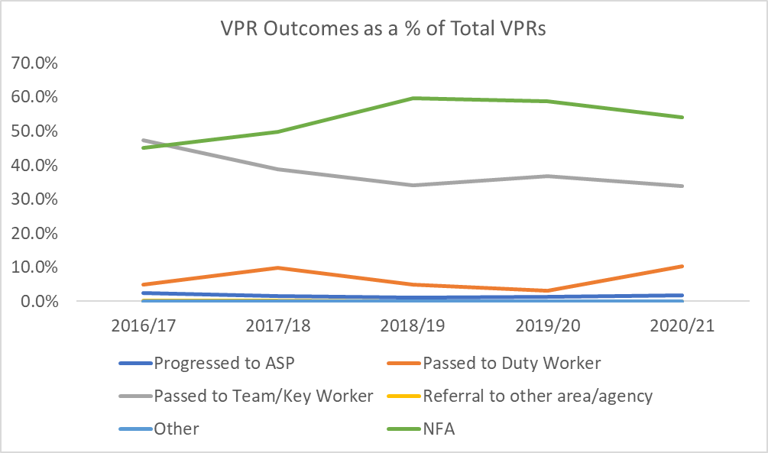

AP Concern Outcomes

  - VPR and AP Concern – analysis
Our data shows a 14% increase in the total number of adult protection concerns received throughout 20/21 in comparison to previous reporting years. Our data also supports that this increase has been incremental over this reporting year rather than any evidence of a spike or a series of spikes since 1 April 2020.
Table 1.10 refers to the AP concerns received by different client categories. The data shows that:
  - There appears to be a proportionate incremental increase across all client categories.
  - The number of AP concerns being submitted where mental health features continues to dominate
  - The data shows an increase in AP concerns being submitted by health.
  - The data also shows that despite the increase in numbers of AP concerns being submitted, 98% of these have been screened within 24 hours of being received.

In this next reporting year, it is the intention to better understand and analyse repeat referrals to see if a number of individuals disproportionately contribute to the overall figures of VPRs and AP concerns received.

Data relating to Adult Support and Protection (ASP) Cases

An ASP “case” is a referral that has progressed to an ASP Inquiry or Investigation.

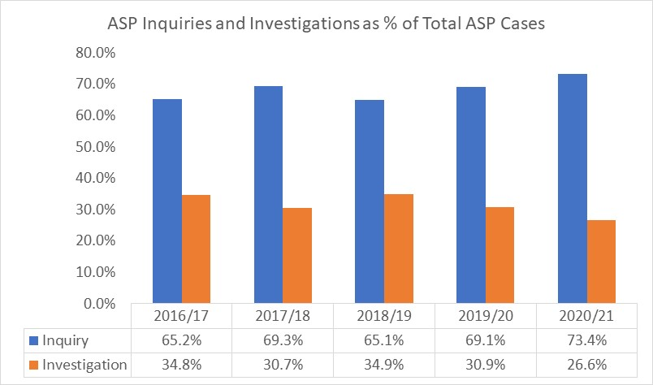
Total number of ASP cases

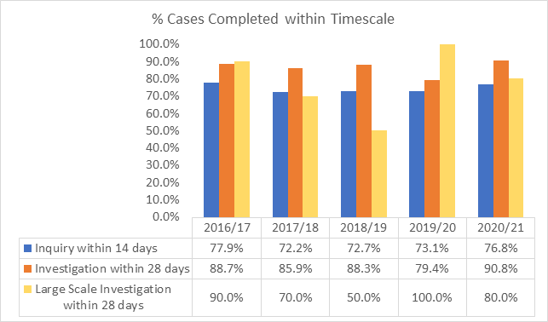

Large Scale Inquiry

All 5 LSIs completed were completed within a care home setting. Despite the increase in AP concerns and AP activity in this reporting year, our numbers of LSIs conducted has fallen.

Some of previous referrals in past reporting years suggested a growing trend in AP referrals relating to care homes supporting those with advanced dementia, aggressive behaviour, and incidents of errors in adults receiving wrong education. A health practitioner was attached to the care home sector to support in these areas and as a result, the number of LSI’s fell. This support to the care home sector has been further strengthened by the care home oversight group within this last reporting year. It is again considered that the support that this group gives to the care home sector and better partnership working gives a greater level of early intervention and prevention that precludes circumstances from within the care home sector reaching that point where the need for an LSI is required.

One area for improvement in this next reporting year is to enhance our communication between services and families, particularly within an LSI. This was highlighted by the multi-agency audit and recognised that whilst there were some examples of good practice across some social work teams, it was also noted that wider involvement and enhanced communication can lead to better quality of care and support.

Outcome of ASP Cases

Note: There should be no cases recorded for more than 28 days under the category Alleged (Investigations Ongoing): all cases should be completed within 28 days.
Breakdown of substantiated and un-substantiated outcomes
Where outcomes have been substantiated as a consequence of AP activity, the greatest impact has been in a review or amended care plan as a means of managing or mitigating the risk following the AP concern being received. The data also supports that there has been an increase in carers support following the outcome of ASP work.

Alleged Perpetrators
Note: In some years there are more perpetrators recorded than the total number of ASP cases, this is because one case can include more than one perpetrator.
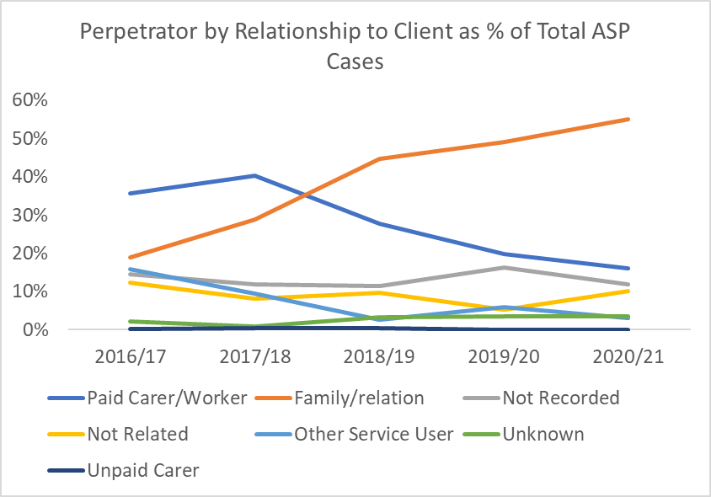

Analysis
The increase in AP concerns received throughout this reporting year has been mirrored in the numbers of ASP inquiries and investigations completed. Our data shows a 22% increase on the numbers of AP Concerns that progressed to formal ASP inquiry or investigation compared to 2019/20.
Despite this increase in activity and the challenges and complexities in working within the Covid restrictions, the data also shows further improvement of those inquiry’s and investigations completed within their respective timelines.
Table 2.2 also gives reference to the outcomes of formal ASP investigation. The data does point towards a significant increase in those with whom an ASP inquiry or investigation was completed considered the adult to be at risk from someone or some people ‘not known’ to the adult.
It is also worth noting that in this reporting year, the numbers of alleged perpetrators ‘not recorded’ has fallen in comparison to previous reporting year. Understanding the context of this is an area of our data collection that we seek to improve on within this next reporting year.
Demographics – data set
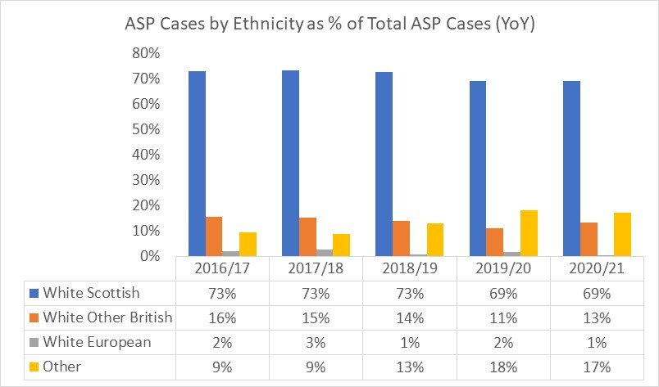
ASP Cases by Ethnicity

ASP Cases by Age Group

ASP Cases by Gender

Demographics – analysis
Analysis of the data shows that there is little change to the ethnicity or the gender of those with whom have had an ASP inquiry or investigation completed in this reporting year. However, the data does show a disproportionate increase in the AP activity for those aged between 16-24. Our data does not identify in which client category that this increase relates to. However, feedback from those who are responsible for overseeing AP work suggest that mental health is a predominant feature of AP inquiry or investigations across this 16-24 age group. This data, has, in part, informed the risk register that is overseen by both the Public Protection Coordinators Group and the Chief Officers Group and as a consequence of the emerging growth of adults at risk within this 16–24-year-old group, identified this, alongside young people in transition between services as an area of priority for joint working as a public protection group.

Adult Protection Investigations (APIs) Only – data set
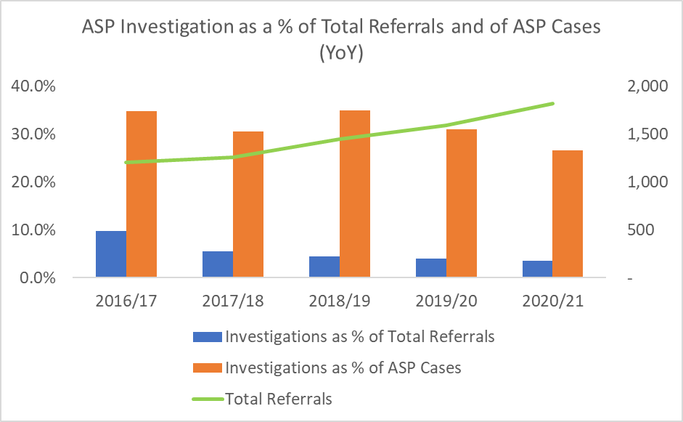

API by Age Group
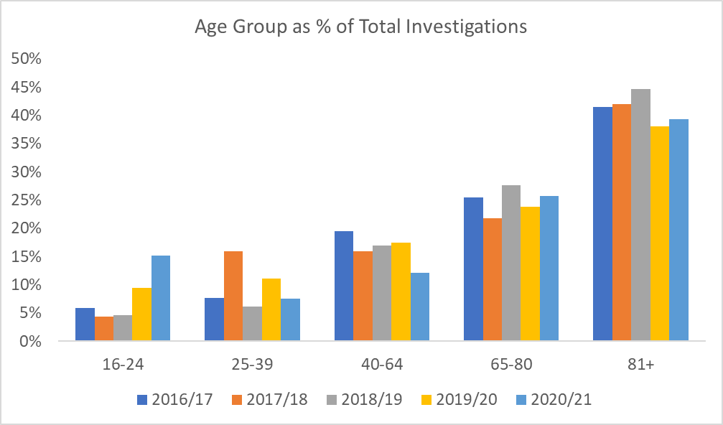

API by Gender
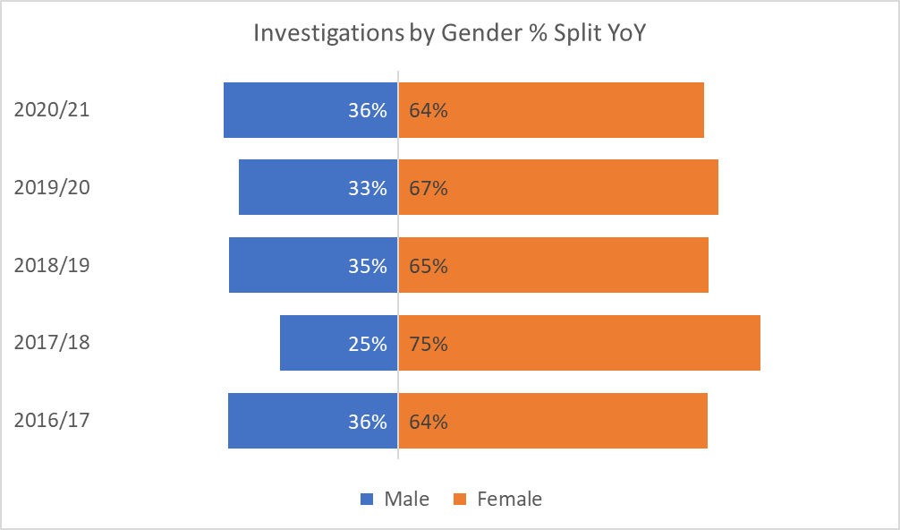

API by Client Group
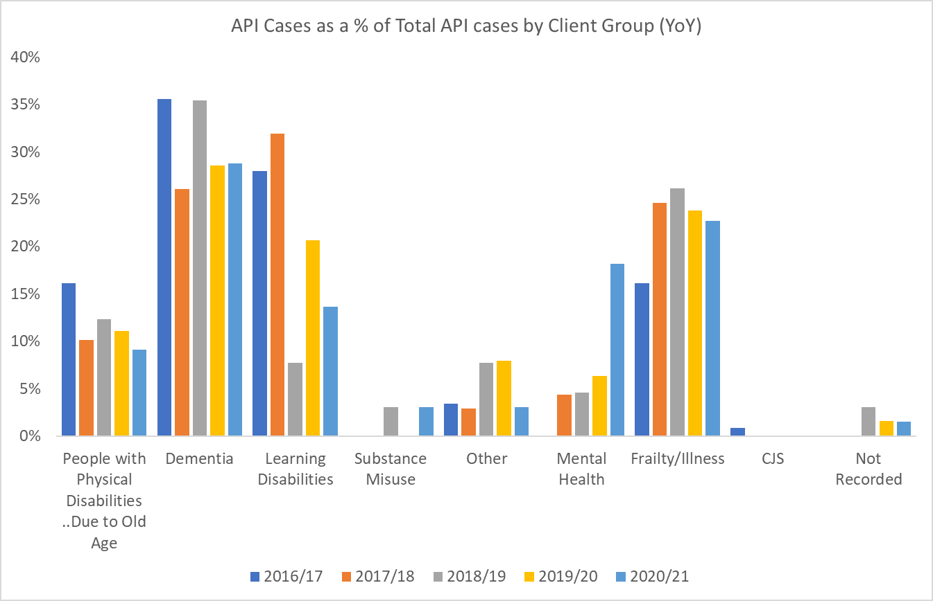

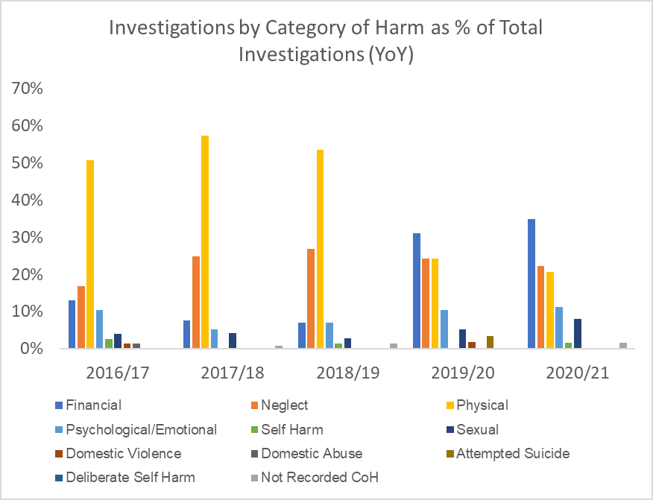
Category of Harm Type

Location of Harm

Adults at risk

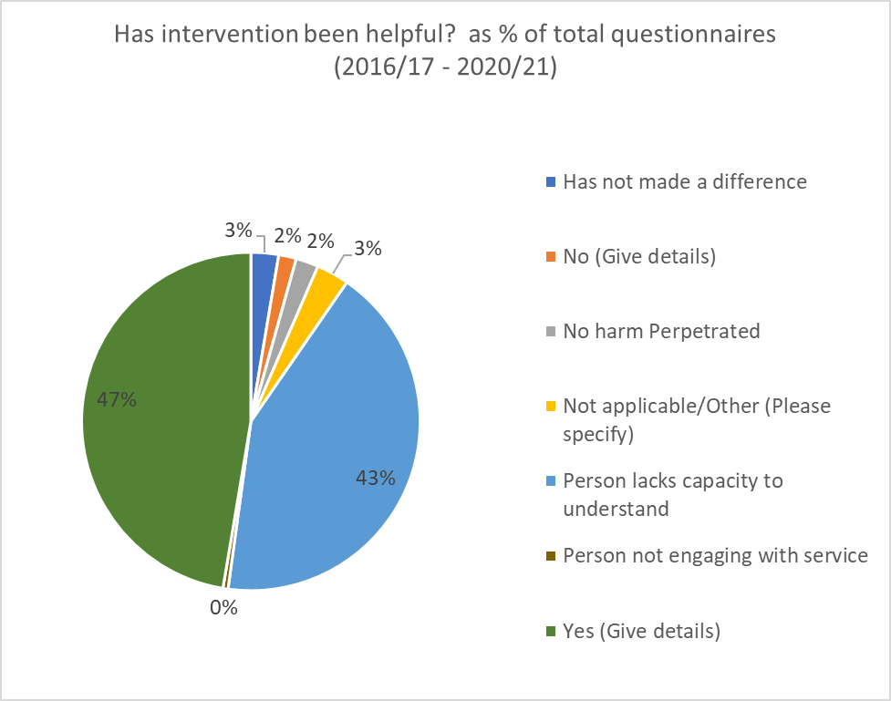

Adult Protection Investigations (APIs) Only - analysis
The percentage of AP concerns progressing to AP investigation has remained unchanged in this reporting year, although one sees a marked increase in the AP referral from both health and police leading to investigation. As noted earlier, there is also a marked increase in AP investigations completed in the age group 16-24, and where an investigation has been completed, our data shows that there has been a 200% increase in investagions completed where mental health is the predominant feature. As will be discussed elsewhere, although it is difficult to link this change directly or indirectly in the data set to the direct or indirect impact of Covid, it does support the early research that the mental health of those who live in societies subject to lockdown and restrictions is likely to deteriorate.
One of our improvements for this next reporting year is understanding better the location of where harm occurs.
Adult Protection and Violence Against Woman
AP sits within the Violence Against Women (VAW) partnership. It is noted within the VAW agenda that there is an increase in violence against woman over the Covid period. We are not seeing this coming through our AP referral or cause for concern reports. Therefore, we are going to focus on this in this reporting year to better understand this position, to forge stronger links and relationships with the partnership and if necessary, offer training and additional support to address any crossover between ASP and VAW and girl’s advocacy.
Financial Harm
Financial harm remains dominant as a type of harm within this reporting year. Research supports that this is anticipated with a significant rise in online fraud. Work has included awareness raising in a number of areas, including the sharing of various scam and bogus fraudulent schemes driven by colleagues in Community Safety, the review and use of the multi-agency Tayside Banking Protocol as a means to safeguard finances of those and a wider awareness on the value and benefit of Power of Attorney and to encourage its uptake.
In this reporting year, we have established and strengthened our relationship with the Advanced Customer Support Senior Leader with the DWP

Adult Protection Case Conferences (APCC) – data set
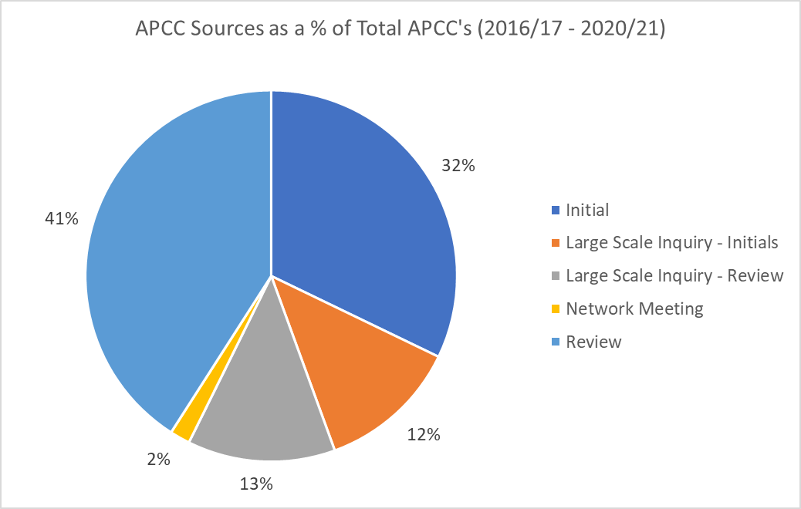

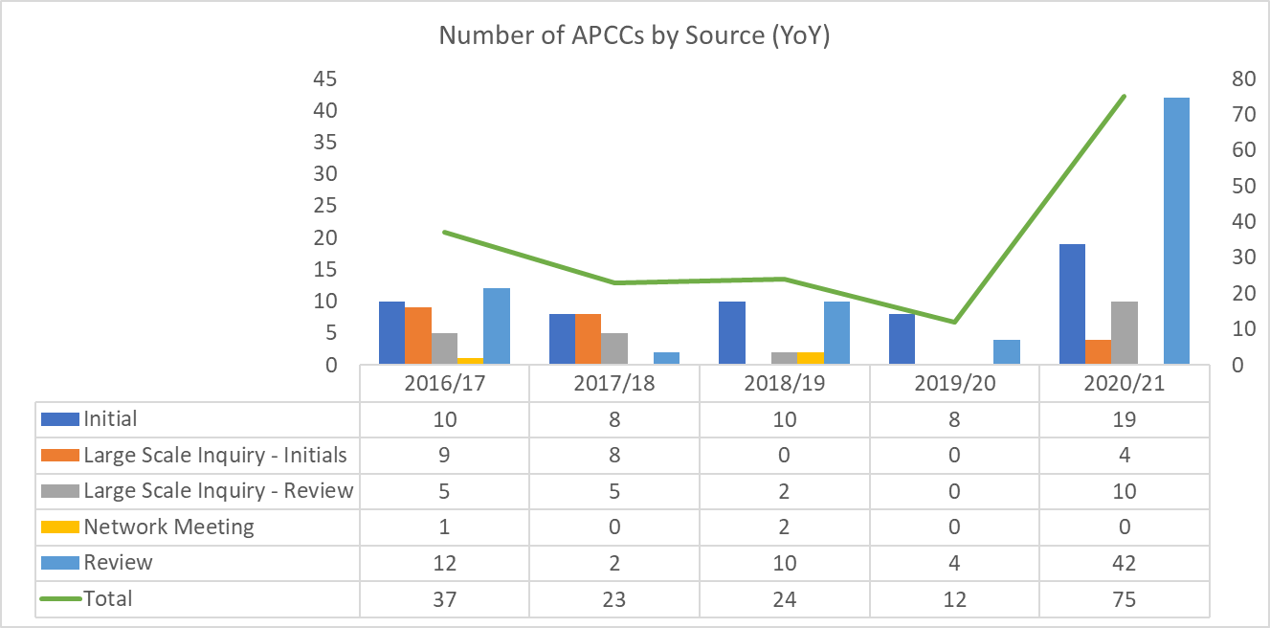

Outcome for Client of Adult Protection Case Conferences
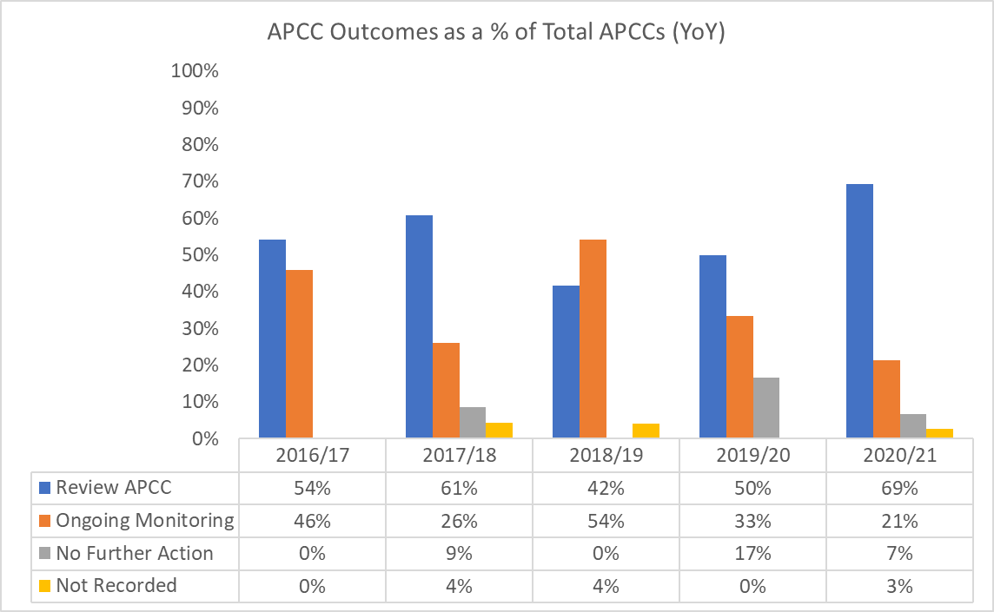

Adult Protection Plans

Protection Orders
In this last reporting year, 3 protection orders have been applied for and granted in Court:

  - A banning order was granted to protect a father from a son where it was considered the son was exploiting his father emotionally and financially

  - A banning order was granted to protect a mother from emotional and physical harm from her son

  - A banning order was granted against a man who was considered to be a sexual risk to a vulnerable female member of his extended family.
This is the first reporting year in which Perth & Kinross Council has applied for a Banning Order. It is difficult to draw any conclusion as to the reasons why this is now the first year in which it is considered a Banning Order is required as a means to safeguard and/or find or draw any correlation or commonality to each of the applications submitted. It is also difficult to determine whether or not some or all of the applications are directly or indirectly related to the impact of Covid. However, one proposed school of thought is that the legal need for a banning order may have felt necessary where there is less likely to be a multi-agency face to face support and supervision across a number of disciplines because of Covid.

We are presently exploring this trend with AP colleagues across Scotland to see if this is a similar trend experienced in other authorities, and from the feedback received, it would appear that the national picture in the use of banning orders is mixed. Some authorities see a similar trend to our own position, some authorities have seen a reduction in the use of banning orders in this last reporting year and some continue to see no reasons to seek to use one as a means of safeguarding. Some authorities propose that the increase in their own use of banning orders relates to practitioners growing confidence and expertise in considering and understanding protection orders. One authority reports an increase in the use of banning orders where substance use has been the main area of risk.

As we come out of Covid, we will continue to monitor if this trend in our use of Banning Orders continues.

- ASP activity and Service Improvements
This section gives attention to what has been done to reduce harm and improve outcomes for adults at risk of harm.
  - The introduction and implementation of Initial Referral Discussion (IRDs) into practice in 2021
Initial or Interagency Referral Discussions (IRD) were introduced into AP practice in this last reporting year. In September 2020 and at the request of the APC, Angus and East Ayrshire concluded an audit into some of our AP activity that did not proceed to case conference. As part of this audit, it was recommended as a service improvement that adult services:
“Consider introducing IRD to involve different agencies in decision making process and the recording of information that partner agencies share”

IRDs have been a long-established practice in Children’s Services as a means to understand and coordinate integrated assessments of risk of harm and risk management plans across social work, health, Police, and other key stakeholders where relevant. It was considered that after ongoing evaluation of IRDs within a child protection context, the implementation of IRDs within an AP context would bring added value to how risk and harm is both seen, coordinated across agencies and subsequently managed.
An IRD is defined as a discussion between two or more services/agencies, where it has been suspected that person has suffered, is suffering or maybe at risk of harm. An IRD must be considered where there is a cluster of concerns in relation to harm.
14 IRDs were conducted between the implementation date and 31 March 2021.
We see the introduction of the IRD process as a significant multi-agency enhancement to how risk is identified, assessed, and subsequently managed. Initial analysis of IRDs in practice highlights how IRDs support quicker multi-agency decision making in relation to how safeguards are implemented.
  - Qualitative audits
The APC continues to conduct self-evaluation and audit into AP activity per year as a way of quality assurance and as a means to identify strengths and areas for improvements
1 - Multi-agency case file & Large-Scale Investigation audit completed
(May 2021)

The audit inspected four completed Adult Protection (AP) investigations that proceeded to Adult Support Protection Case Conference (ASPCC). Two of the four cases were chosen given their complexity leading to numerous case conferences within the chosen audit period. This audit also looked at two LSIs completed within the audit period using a similar methodology, reference points and information held on AIS, EMIS and Police records.

2 – Police Vulnerable Police Reports (VPRs) and AP Concerns Received
(June 2021)

This audit inspected the AP practice relating to the process and the decision making of a sample of 48 VPRs and AP concerns received by Social Work.

3 – Conversion of AP investigation to AS case conferencing
(Dec 2020)

Perth & Kinross has, year on year, had one of the lowest conversion rates of completed ASP investigations that proceed to ASP case conferences. The APC agreed to ask colleagues from both Angus and North Ayrshire, both of whom have the highest conversion rates to audit a sample of investigations to look at the application of threshold and decision making and give assurances to practice.
The conclusion of all 3 audits reveals strong practice across our AP activity and a number of areas highlighted in previous audit’s that had improved within this reporting year, including a clear multi-agency approach to safeguarding, particularly within our more complex areas of AP work incouding our Large-Scale Inquiry’s. The audits also highlighted a number of areas that required improvement incouding how we can support relatives better with regular and scheduled meetings for those implicated within an LSI and the provision of quality and consistent multi-agency chronologies
  - Feedback from Organisations
As part of the multi-agency audit work, the care home manager, and the care home regional manager where one LSI was conducted were interviewed for their feedback on the LSI process. Although both indicated that they felt the initial reason for instigating an LSI was unnecessary, both acknowledged that they found the content of the investigation helpful in terms of bringing change and improvements to practice. The regional manager of the care home group is also regional manager to a number of care homes across the North of Scotland. He shared the view that whilst he thinks that Perth & Kinross has a lower threshold for instigating an LSI in comparison to other authorities, it is also his view that Perth & Kinross brings a greater level of support to the care home sector (see HSCP Local Enhanced Care Home Oversight Group)
  - NHS Tayside AP Team Annual Report 2020
This annual report sets out the position of NHS Tayside in relation to its role in AP activity throughout 2020 and the key priorities for 2021/2022.
  - Public Protection (strategic) Group and Public Protection Workforce Development

In this last reporting year, a multi-agency Public Protecting Group was established and led by our CSWO with membership from all agencies with a responsibility for protection of those considered to be at risk or are considered a risk. This group extends to membership from Child Protection, Adult Protection, Violence Against Women Partnership, Alcohol and Drug Partnership, Community Justice Partnership, MAPPA, and Safer Communities.

One of the main actions of the group was the development of a risk-register and a weekly data set of key information to address the changing ‘safeguarding’ landscape brought about by COVID 19. Our position is one where we believe that establishing a PPG, underpinned by a risk register with governance and scrutiny from senior management has offered the opportunity for services that share a similar safeguarding agenda to be strengthened throughout this reporting year. Although initially established because of the impact of Covid, evidence shows that the group brings value to the shared agenda and therefore, commitment has been already been given that the PPG will continue as a multi-agency group post Covid.

  - Public Protection (Practitioner) Group

Although not essentially driven by the defining criteria that underpins ASP, the Public Protection (practitioners) Group supports those considered vulnerable and who may not be able to safeguard their welfare and/or other interests. The group was established during the height of the COVID pandemic as a means to bring a coordinated and multi-agency approach to the support of those considered vulnerable. In the absence of traditional face to face contact with many services, it was recognised that some other (non-traditionally caring) roles, such as housing, the third sector supporting housing colleagues and welfare rights may well be in contact with those who may appear more vulnerable as a consequence of the restrictions placed upon society. Therefore, establishing this group of practitioners across a number of disciplines (that met weekly and continues to meet weekly) created the opportunity for practitioners to bring to the group concerns with a view to establishing a multi-agency response. The nature of the group and its membership actively promotes the concept of professional curiosity and the principles of professional curiosity that lie therein. Through review and self-evaluation, although we appear to be moving out of crisis and into what may appear to be a new normal, there is sufficient value in this group for it to continue.

  - Enhanced Care Home team

The Enhanced Care Home Team (ECHT) was established within this reporting year as a national programme of enhanced investment in the provision of a multi-agency response to supporting the care home sector. This programme of work acknowledged the increasing challenges faced by care homes in supporting adults with increasing complex needs, incouding supporting those with acute levels of dementia, learning disability, mental health and acquired brain injury, all within the context of supporting an extremely vulnerable group throughout the Covid-19 pandemic. The ECHT is made up of dedicated social work provision, various nursing and health care posts and a leadership and governance structure from within the Health and Social Care Partnership. The social work role within this team has a focus on supporting AP activity across the care home sector. One of the NHS AP advisors is also aligned to the HSCP. This provides a greater level of targeted assurance in relation to AP activity across this sector.
6.8 Serious Case Review (SCR) - MR A
The APC completed its first serious case review earlier this year into the care and treatment received by Mr A. The review acknowledged that improvements are required across a number of areas including our pressure ulcer and tissue viability policy and practice and learning points around record keeping, discharge planning and transitions of care. The learning summary can be found at:
https://www.pkc.gov.uk/media/47975/Mr-A-Learning-Summary-10-March-2021/pdf/Mr_A_Learning_Summary_(10)_March_2021.pdf?m=637515675651370000
The SCR made 25 recommendations which have been translated into a dedicated SCR improvement plan. A multiagency short life working group has been established across both HSCP and acute health services to progress these improvements. This work reports back to both the Adult Protection Committee, the Chief Officers Group and the Clinical Care and Governance forum.
As part of the learning from the Mr A SCR, a 7-minute briefing of the review has been presented to a range of practitioners and senior officer scrutiny and governance groups.
The APC and COG receive assurances of the progress of the SCR improvement plan.
6.9 Initial Case Review (ICR) Mrs C
Within the reporting year, an ICR was concluded into the circumatces for Mrs C prior to her death. The review acknowledged a number of learning points, including learning around self-neglect, hoarding and how capacity informs practice.
6.10 Capacity assessments
It is recognised that from this ICR and other learning reviews across Tayside where capacity/incapacity features, that an established Tayside capacity assessment pathway is required to support a multi-agency response and early decision making about how to support someone where capacity to safeguard welfare and other interest is not clear. A Tayside wide short life working group across Tayside has established to take this work forward. P&K is represented on this group.

- Training, Learning and Development
Evaluation: We are confident that we are developing a competent, confident, and skillful workforce. Our staff are highly motivated and committed to their own continuous professional development. We are empowering and supporting our staff with a wide range of evidenced-based multi-agency learning and development opportunities, which are evaluated highly and having a positive impact on practice. The content of these learning and development opportunities takes account of changing legislative, policy and practice developments and local challenges.
  - Staff learning and development
The APC continues to be committed to the delivery of awareness and specialist training to all partner agencies to ensure staff can recognise and respond to any identified or suspected harm. Prior to the pandemic, this was delivered online and in face to face. However, much of the focus this reporting year has been managing the complexities of the challenges that practitioners have faced, and where the opportunity for training existed, trying to adapt an existing traditional model of training for it to be delivered virtually without losing its integrity.
  - Council Officer training

Council Officer training has been redesigned to be delivered in partnership across Tayside on a blended learning basis. This new comprehensive programme model aims to support practitioners with the knowledge, skills, and experience to enable them to lead on adult support and protection investigations and undertake all aspects of the ASP Council Officer functions competently and confidently.

This programme was piloted in January 2021 with first Tayside wide cohort being delivered in August 2021 and cohort 2 in February 2022. The programme runs over 9 workshop sessions alongside an online resource and supported learning tool. The learning tool enables practitioners to develop individual learning plans to facilitate and evidence their learning throughout and beyond the programme.

  - Safeguarding those in crisis, suicide prevention, community engagement and lessons learned for ASP in 2021/22
Restrictions on movement and face to face contacts rendered a number of people vulnerable for a number of different reasons.
  - We heard that people who were in difficult/abusive relationship found it difficult to find that safe space to make a call into services that would ultimately seek to keep them safe.
  - People who were engaging with services online or over the telephone found it difficult to truly engage in services due to a number of different reasons. For example, it was reported that some had issues related to IT, childcare issues or it was reported that the same reasons that some were seeking ‘safeguarding’ support stemmed from the risk within the household. As a small representation of how IT could be used as a means to compliment service delivery (rather than replace it), 20% of those being supported by a community-based support team in July 2020 reported that they would engage in support via IT.
A short life working group was established with community leaders to scope out the possibility of some safeguarding services being delivered from community spaces. This was with a view to:
- Improve engagement with communities
- Harness the contribution of the community and voluntary sectors to bring in additional resources
- Roll out community conversation methodology across localities
- Allow the opportunity to tie in AP, CP, housing, violence against women (VAW), alcohol and drug partnership (ADP) and other inter-related safeguarding strategies.
- Promote safer communities through partnerships with community planning, police, and communities themselves
- Promote the integration of IT into service delivery with the use of ‘near me/attend anywhere or equivalent

  - Reducing the prevalence of suicide, self-harm, distress, and common mental health problems by:

- Continue to develop and extend accessible community assets and non-clinical sources of support
- support to empower people to protect and improve their health and wellbeing
- Maximise opportunities to promote wellbeing through technology
- Provide support to those who face physical, emotional, economic, or cultural barriers to accessing community supports
- Further develop the suicide prevention webinars and seek to embed the P&K suicide prevention within the healthy community strategy. Review mental health awareness and suicide prevention training, identify gaps, and develop a strategic approach to delivery
- Maximise community assets and opportunities to drive key messages about wellbeing
- Evaluate the impact of Community Based Programmes in preventing common mental health problems
- Frontline staff in its broadest context have the skills, competencies, and confidence to deliver on Distress Brief Interventions (DBI)
- People are signposted to services appropriate for their needs

This community engagement remains a key opportunity identified across a number of safeguarding agendas being taken forward throughout this next reporting year. Raising awareness and being able to respond appropriately and proportionally to any ASP concern is a key area for 2021/22.

  - Trauma Informed Practice
Since 2018, commitment has been given across both the ASP and CPC agenda to have a trauma informed workforce and is an example of jointly commissioned training between the APC and the CPC. We have:
- Published and disseminated P&K Trauma Informed Practice Guidance for practitioners working with children, young people, and adult survivors of CSA / CSE.
- Commissioned two multi-agency Trauma Informed Managers Briefings: three multi-agency Trauma Informed Practice Training Sessions and two multi-agency Trauma Informed Practice Resourcing Workshops.
- In 2021, commitment was given to the commissioning of further trauma informed managers briefings and a series of training on trauma informed practice for practitioners across child and adult protection and other supporting/safeguarding roles. Extending this training for a further year indicates that the delivery of this is a considered a positive piece of work in terms of collaborative working between the two committees.

  - NHS E-learning Adult Support and Protection Learnpro Module
As of January 2021, 10908 practitioners across all areas across Tayside had completed the online ASP module
The AP learning module is also hosted by PKC. The module is available to employees as well as being made publicly available on the www.pkc.gov.uk webpage. Between 1 April 2020 and 31 March 2021, the module has been accessed on 828 occasions.
  - ASP Matters
ASP matters is a practitioner led peer support network for those who practice in and/or are involved in AP work. Supported by our colleagues from learning and development, it is an open forum for practitioners to discuss practice and use the experience from within the peer group to share and learn from each other. The practitioner lead for ASP Matters sits on the APC sub-group and provides a link from ASP matters into ASP practice. ASP matters meets monthly via MS Teams. It is not exclusive to Council Officers, but an offer of a safe, learning space for those who have a vested interest in AP work.

  - Looking forward
We continue to explore and commit to the AP training needs analysis of the workforce. We also look to strengthen our relationship and the training opportunities that exist at a Tayside level. The AP training plan looking forward includes the following:
- The development of a Tayside ASP minimum learning standards action plan which will include the following:
  - ASP Tayside Council Officer Programme (Level 3)
  - Defensible Decision-making Programme (Level 2/3)
  - Tayside multi-agency introduction to ASP (Level 1)
  - ASP Hospital Discharge development
  - Tayside Hoarding and Self-neglect
  - 2nd Interviewer Training
From a learning and development perspective, we also seek to achieve the following in the next reporting year:
  - Lead Officer Tayside workforce learning and development priorities 2022/23
  - Create and sustain a Tayside ASP MS Teams Projects/Channel
  - Develop a Tayside ASP Communication plan
  - Develop a number of Tayside ASP Practice Forum/Learning exchange events 2022

- Engagement, Involvement and Communication
Evaluation: We are confident that we listen to, understand, and respect the rights of adults at risk and their families and that we are helping them to keep themselves safe.

Independent advocacy is an important consideration in ASP cases to ensure that the adult and family views remains is represented and it is our position that it is key that advocacy is involved at the earliest point and throughout the ASP process . The support adults receive is well evaluated and audits evidence that independent advocacy is offered to the majority of adults at risk.
Clare Gallagher, Chief Executive for IAPK writes:

“There is a commitment from P&K to support referrals to independent advocacy and from IAPK in prioritising these cases. Good working relationships have been fostered between P&K and IAPK which include representation from independent advocacy on the APC, ASP Subgroup and ICR/SCR Group”

In this reporting year, IAPK has supported AP activity on 55 separate occasions.
Clare Gallagher is an active member of the APC.

  - Feedback from service users and Carers
Research supports the value in engaging service users in designing, co-producing, and implementing policy and procedure There are different ways in which the APC gains feedback from service users and carers:
  - Questionnaires are completed at Adult Protection Case Conferences (APCC).
  - Participation in audits to give their views
  - The committee has 2 Carer representatives
  - Analysis of outcomes on all ASP forms. In order to capture impact of intervention for those cases which did not proceed to APCC, an outcome question was developed to be completed at end of the ASP case. The staff member completes the form with the input of client to check if the intervention has been helpful.
Service user and Carers views are at the centre of the work we do, and it remains a priority for the APC.
The APC has taken a variety of steps to address this. However, this can be complicated because of:
  - Levels of understanding
  - Communication issues
  - Conflict within families

However, if we If we look elsewhere, there are examples of practice that we can learn from, including the implementation of a regular, local service user forum, similar to our ASP matters forum which may allow for a systematic approach to gathering on reporting on service user involvement and feedback

  - Communication and public awareness

We have developed the APC webpage which provides public information that is accurate and relevant. We are working with community groups to address issues identified as areas that could impact on our ability to safeguard people. In recent years we have tried to raise awareness in a variety of different ways and different formats e.g., Facebook, Twitter. It has been difficult to gauge impact of these initiatives as they do not necessarily generate referrals but tend to focus on raising awareness more generally.

The dedicated ASP webpages (Perth & Kinross Council - Adult support and protection (pkc.gov.uk) throughout this reporting year have been visited on 1330 occasions. Whilst this is significantly lower than in previous reporting years, PKC IT has implemented a new security software policy on all of the PKC webpages that has implications on understanding the number of times any PKC webpage has been visited.

Mary Willis, Communications Officer states:

“During the past year we have supported national social media campaigns either directly relating to adult support & protection, or allied to this area of care and support:
- National Elder Awareness Day 2021 (February)
- #ShutOutScammers (joint Police Scotland and Trading Standards)
- Domestic violence and forced marriage

We also undertook local campaigns on social media to share information around how people can report concerns about adults at risk of harm during the initial stages of the pandemic, in a similar way to those done for child protection”.
8.3 Sustaining close safeguarding relationships with wider organisations
The APC has a wide membership including a representative from University of the Highlands and Islands (Perth College campus). The campus has students with a range of physical and learning disabilities and those with whom have disclosed a mental health support need. Retaining this close working relationship, particularly during the challenges posed by Covid has been key to ensuring that those who are considered vulnerable, at risk or in need of support from wider agencies are able to access this.
In 2020, a number of meetings took place with community and faith groups and the wider public protection groups to work jointly and communicate a shared ‘safeguarding’ vision. As a consequence of this, it was agreed that a ‘safeguarding’ leaflet was produced across a number of different languages as a means to reach out to those with whom English is not their preferred language. This has been done in partnership with our third sector colleagues from PKAVS.
- Looking Forward
This report has identified key areas for our programme of work over this next year. We continue to focus on understanding the impact of Covid 19 and the subsequent lockdown on AP activity within P&K as well as understanding the impact on AP activity nationally. This includes a particular focus on our continued use of banning or other legal protection orders as a multi-agency and coordinated means to safeguard.
We will give a focus on key issues such as violence against women, financial harm, understanding the AP impact on those where drug and alcohol features, mental health, and suicide prevention.
Priority will also be given to supporting the emerging prevalence in AP activity around the young adult and those young people and adults in transition between services. This has been highlighted within this report as an area of priority across the wider public protection agenda and an area that requires a multi-agency, coordinated response.
In this coming year, we are keen to explore how we can engage service users in a more meaningful way and developing an AP-specific communications strategy would help promote the importance and relevance of adult support and protection.
This report has highlighted the need for a robust, reliable data set from across all partner agencies to inform planning, manage workload efficiently, target resources on key issues, to inform improvements to practice, and to demonstrate outcomes. As we continue to move towards commissioning a new social work database, it is intended that this new system and the data produced from it will help better understand and improve performance and outcomes. This will also be informed by any plans to implement a national data set.
Capturing learning from adverse events and different learning reviews has been identified as important and work with partner agencies across Tayside, including colleagues from CPCs has already began to explore how this can be taken forward as a means to learn from the significance of past events.
We acknowledge the importance of chronologies as a means to identifying patterns of behaviour, escalating risks, strengths, and weaknesses of the adult. Our audit into some of our own AP work identified that works need to be done in this reporting year to ensure that our multi-agency chronologies are available, up to date, focus on key life events and the implications of these on risk, risk assessments, risk management plans, and chronologies are consistently shared among all our adult protection partners.
- Our response to Covid–19
Much has been referred to within this report about how our AP activity and our practice has been impacted or indeed influenced by the coronavirus pandemic, not only in the way we practice but how Covid and the restrictions therein have impacted on those who require support. COVID-19 undoubtedly created a global health and social care crisis that significantly impacted on adult safeguarding practice. We know from research that the impact of self-isolation, those who required to shield for periods, social distancing and limited and restricted community resources placed additional pressures on the most vulnerable in our community. We also know from more recent research that societal restrictions have led to an increase in violence against women. Although this does not reflect in our data, our close working relationship with the VAW agenda will seek to explore this going forward.
In the early phases on the pandemic, face to face contact in safeguarding was reduced and only considered absolutely necessary. Throughout this reporting year, services, including Council Officers have in part, relied on digital technology and telephone communications because of government lockdown restrictions.
  - Working from home/remote working
  - Daily reporting of available council officers to carry out AP work
  - Daily review of AP work to ensure sufficient council officers
  - Temporarily moved to 7-day working to support our Out of Hours colleagues
As stated earlier in this report, adult protection was considered a key multi-agency priority and as a consequence, scrutiny and governance was given to it from a number of areas.

However, despite these challenges, improvements to AP performance and practice in the most challenging of years has been made. Our data supports that notwithstanding the professional and personal challenges faced by practitioners as a consequence of covid and practising within the layers of restrictions, our AP concerns received increased by 14%, but our screening of these within 24-hours also increased. The numbers of AP inquiries and investigations completed within timescales increased. Data also supports that the number of APC case conferences increased from 12 conducted last year to 75 conducted this reporting year. Therefore, alongside the pressures and complexities, the actual AP workload in this last reporting year increased significantly. This requires close monitoring.

It is also considered that despite these complex challenges brought by Covid, the wider AP agenda has forged and strengthened relationships with a number of other key adult safeguarding strategies, and the growth of the Public Protecting Group and the scrutiny and governance given to Public Protection supports this statement. Whilst the lack of face-to-face contact has its disadvantages, Perth & Kinross has committed to and embraced MS Teams. It is widely recognised across practitioners that the use of MS team has allowed for greater connectivity, and whilst digital and virtual AP assessments will always be seen as appropriate only in defendable circumstances, evidence exists within staff surveys that it is now easier to connect with others as a means to share and safeguard.

It has been difficult to quantify the impact of Covid on AP activity. There is no doubt that the numbers of AP concerns received including VPRs have increased, and within this increase, there is a marked prevalence of those experiencing distress, are in crisis and/or features a wider mental health concern. Much of our early practice in the initial phases of Covid was influenced by the limited research available about how society reacts to a pandemic and degrees of restrictions. This research, albeit limited, pointed to individuals and communities experiencing deteriorating mental illness as a consequence of increased and prolonged stress, anxiety, isolation, and indirect consequences around loss of income. Our data and our analysis of this suggests that this may well be the case. Consequently, and following analysis of this data, services across statutory and voluntary sectors have been re-shaped in order to drive these AP concerns into a multi-disciplinary triage system to steer and signpost into the most appropriate and proportionate mental health provision, all within the context of AP. The outcome of this will be reviewed and evaluated as part of this ‘test of change’.

Summary

This report seeks to give analysis to the AP activity and its impact between 1 April 2020 and 31 March 2021. It highlights a number of key areas where our multi-agency AP activity within Perth & Kinross is strong, and it identifies areas in which we seek to improve. If the improvement areas as highlighted within this report are approved at AP Committee, these will inform the APC Improvement plan for 2021/2022.

Iain Wilkie
Adult Protection Coordinator
25 August 2021

https://www.nrscotland.gov.uk/files/statistics/council-area-data-sheets/perth-and-kinross-council-profile.html#population_estimates
https://www.scotlandscensus.gov.uk/census-results/at-a-glance/population/
A VPR is a report submitted by Police Scotland. An AP Concern is any other AP concern submitted by health, family, other support agency etc.
AIS and EMIS are the Social Work and Health data bases
First Annual Report: NHS Tayside Adult Protection team; January 2020 – December 2020
https://www.nhstayside.scot.nhs.uk/OurServicesA-Z/NearMeTayside/index.htm
The suicide prevention agenda commissioned Dundee University to deliver online training around supporting people in distress, crisis and those who are actively suicidal. This training extended to community leaders and active members of different communities across Perth & Kinross. In total, 210 people took part in the virtual training.
First Annual Report. NHS Tayside Adult Protection Team January 2020 – December 2020. P:7

