**DIRECTIONS FOR THE REGISTRATION SERVICE**

**DISTRICT OF PERTH AND KINROSS**

In accordance with sections 14(1A)(b) and 23(1A)(b) of the Registration of Births, Deaths and Marriages (Scotland) Act 1965 (as amended by the Coronavirus (Recovery and Reform) (Scotland) Act 2022), and with the approval of the Registrar General, the District Registrar for the registration district of Perth and Kinross directs as follows, with effect from 24 September 2022.

In this district, the permitted manner(s) of giving the prescribed information to the registrar during a remote registration of a BIRTH is by telephone, by online call or by email*.*

In this district, the permitted manner(s) of giving the prescribed information to the registrar during a remote registration of a STILL-BIRTH is by telephone, by online call or by email.

In this district, the permitted manner(s) of giving the prescribed information to the registrar during a remote registration of a DEATH is by telephone, by online call or by email.

Signed 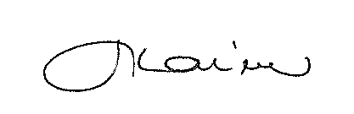District Registrar

Dated 14 September 2022