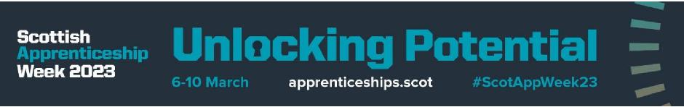
Congratulations to five of our young people who have achieved their SVQ qualifications and completed their Modern Apprenticeships in Business and Administration, Social Care and Housing in the last 3 months!
Looking back over the past year, it’s fantastic that 18 modern apprentices have successfully completed their qualifications and many have secured employment with us or our partners!
Huge thank you to our inspiring leaders who support the apprentices through their learning and share their knowledge of working with us! We couldn’t do it without you!
Scottish Apprentice week
As a Young Peron’s Guarantee Employer, we’re proud to support the Scottish Apprenticeship week, celebrating how modern apprentices are #UnlockingPotential with us, our local partners, businesses, people and the UK economy.
During the week in March 2023, our Employability Team were out and about in schools and the local community, promoting the benefits of apprenticeships to prospective new modern apprentices!
Rachel, a modern apprentice within our Reach Team and Louise, one of our newest apprentices shared their experience of being a modern apprentice with us. Massive thank you to both as we know it can be daunting sharing your pics on social media.
Modern Apprentice Awards
Congratulations to Louise Lawson who won the Modern Apprentice of the year 2023 completing a Business and Administration qualification within the Independent Living Partnership (ILP) in our Health and Social Care Partnership. Louise has continually shown her commitment to delivering high quality work.
She demonstrated confidentiality and integrity, promoting positive values and anti-discriminatory, non-judgmental practice. Feedback from her mentor and team underpins why Louise has won this award: “It is a pleasure to have been a work colleague of Louise who is an inspiration to all staff. Louise is a conscientious, caring, considerate, honest and diligent young individual who I have no doubts will go far in her career. On behalf of ILP, we all feel truly honoured that we have been part of her employment and life journey. We cannot think of any individual more deserving of this award”.

Congratulations also goes to Laura Fraser who won the Modern Apprentice Supervisor of the Year Award! Laura has demonstrated that “if you really want to be a successful leader, you must develop others leaders around you and #UnlockPotential.”
Her Modern Apprentice shared: “Laura has been amazing from the start. She is always willing to give a helping hand if I needed it and I couldn’t have asked for a better mentor”.

Thank you to Zellis for sponsoring our Modern Apprentice Awards this year.

