Langlands, Luncarty
Play area relocation and renewal
Contact: Nick Riley, PKC Landscape Architect
Marshall Way
communitygreenspace@pkc.gov.uk

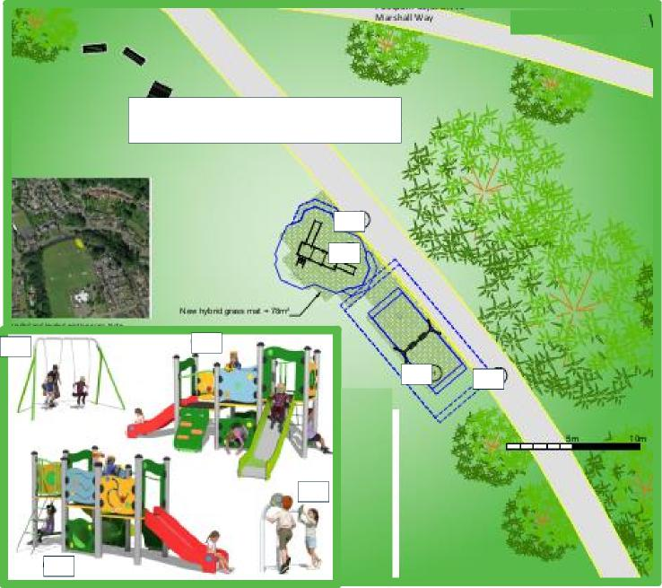
01
03
Footpath from Marshall Way To housing and school
03
02
03
02
01
02

