
Memorial Bench Enquiry - Cemeteries
Thank you for your interest in placing a memorial bench in one of our burial grounds. If you would like to take your enquiry forward, please complete and email the form to ESBurials@pkc.gov.uk or send it to:
Perth Crematorium, Perth and Kinross Council, Crieff Road, Perth, PH1 2PE
You can also visit our website for more details: www.pkc.gov.uk and search for memorial benches.

Summary of Conditions
- The cost to purchase a 5’ Learmonth Glen Isla memorial bench (pictured below) with a plaque is currently £1,176 (including VAT).
- The ongoing maintenance of the bench is the responsibility of the customer.
- Benches that are not maintained and fall into disrepair may need to be removed from the cemetery.
- We may occasionally need to relocate or temporarily remove benches from the cemetery to allow for maintenance or refurbishment works.
- The Council cannot guarantee against theft or vandalism and may not be able to replace either the bench or plaque in this occurs.
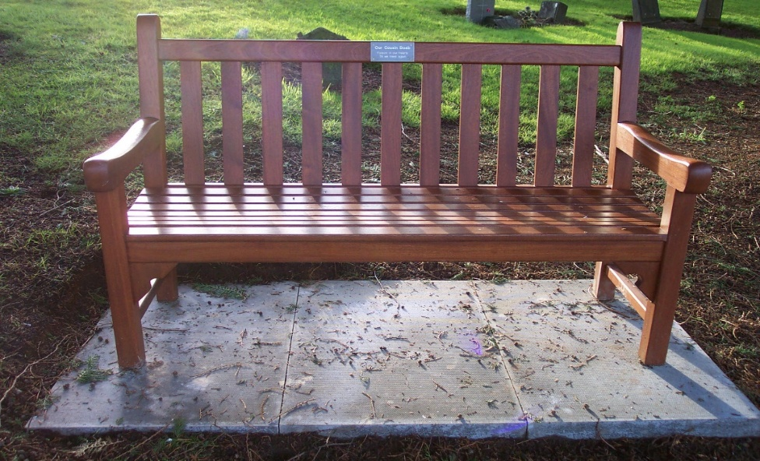
Once we receive your enquiry, a member of our team will get in touch to let you know whether it’s possible to place a memorial bench in your chosen burial ground and location.
Your enquiry will remain open for up to 8 weeks from the date it is sent to you. If we don’t receive your completed form within that time, the enquiry will be closed and removed from our records. You are always welcome to contact us again and reapply.

Memorial Bench Enquiry Form
Please complete and email to ESBurials@pkc.gov.uk or send it to:
Perth Crematorium, Perth and Kinross Council, Crieff Road, Perth,
PH1 2PE
How we use your personal information
The information provided by you will be used by Perth and Kinross Council for the purpose of processing and administering your request, maintaining accurate records, and contacting you regarding installation, maintenance, or future renewal of the memorial. The information will not be disclosed to third parties except as described below.
The Council may check information provided by you, or information about you provided by a third party, with other information held by us. We may also get information from certain third parties or share your information with them to verify its accuracy, prevent or detect crime, protect public funds or where required by law.
For further information, please look at our website www.pkc.gov.uk/dataprotection, email DataProtection@pkc.gov.uk or telephone 01738 477933.

Section A: Your contact details
Name:
Address:
Telephone:
Email:

Section B: Bench location
Please specify the name of the cemetery and the desired location within the cemetery. The bench will be placed in an agreed location which will cause the least disruption to maintenance works.

Section C: Memorial plaque
All plaques will be provided by the Council via the supplier and attached to your bench. Please print your memorial plaque message below. The message usually consists of a maximum of 40 letters but if more is required then an additional charge will be levied. The wording will be subject to Council approval. Any specific requests like punctuation and style of grammar must be made clear on this form as Perth and Kinross Council will not be held liable for the replacement of a memorial plaque.

Date sent to customer:
If you or someone you know would like a copy of this document in another language or format, (on occasion, only a summary of the document will be provided in translation), this can be arranged by contacting the Customer Service Centre on 01738 475000.
You can also send us a text message on 07824 498145.
All Council Services can offer a telephone translation facility.
BSL users can contact us via Contact Scotland BSL, the online British Sign Language video relay interpreting service. Find out more on the Contact Scotland BSL website.

