Education Maintenance Allowance
Part D1 - 2026/2027 Parent/Carer 1
This form must be completed by the Employer and should accompany the Education Maintenance Allowance Application Form - but only if you do not have a P60.
Name of EMA Applicant
Name of School/Base
Employer’s Certificate
Mother/Stepmother/Father’s Partner/Carer 1
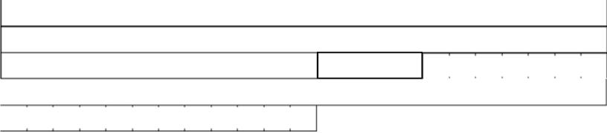
Postcode
Name (in BLOCK LETTERS) Address
Occupation
Works Tel
To the Employer: Please provide details of the total gross income for the above named person for the year to 5 April 2026.
If employed for less than 12 months, give their start date D D M M 2 0 Y Y
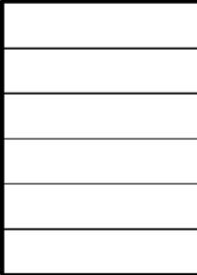
£
£
£
£
£
£
- Total gross income (prior to the deduction of superannuation, Income Tax, etc) in my/our employ
Bonus
Overtime
Other (free meals, etc)
- Total gross pay in respect of previous employment(s) and taxable
benefits. Total Gross Pay for Year to 5 April 2026
Employer’s Stamp
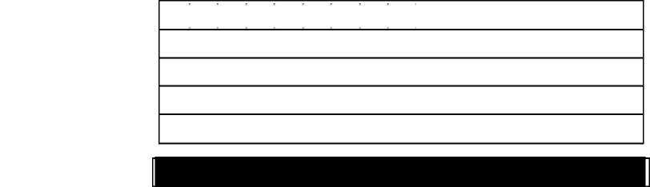
Employer’s Name Employer’s Address
Postcode
Employer’s Signature
Date D D M M 2 0 Y Y

Education Maintenance Allowance
Part D2 - 2026/2027 Parent/Carer 2
This form must be completed by the Employer and should accompany the Education Maintenance Allowance Application Form - but only if you do not have a P60.
Name of EMA Applicant
Name of School/Base
Employer’s Certificate
Mother/Stepmother/Father’s Partner/Carer 2
Postcode
Name (in BLOCK LETTERS) Address
Occupation
Works Tel
To the Employer: Please provide details of the total gross income for the above named person for the year to 5 April 2026.
If employed for less than 12 months, give their start date D D M M 2 0 Y Y
£
£
£
£
£
£
- Total gross income (prior to the deduction of superannuation, Income Tax, etc) in my/our employ
Bonus
Overtime
Other (free meals, etc)
- Total gross pay in respect of previous employment(s) and taxable benefits. Total Gross Pay for Year to 5 April 2026
Employer’s Stamp
Employer’s Name Employer’s Address
Postcode
Employer’s Signature
Date D D M M 2 0 Y Y

How We Use Your Personal Information
The information provided by you will be used by Perth and Kinross Council to (to assess eligibility for Education Maintenance Allowance). The information will not be disclosed to third parties except as described below. The Council may check information provided by you, or information about you provided by a third party, with other information held by us. We may also get information from certain third parties or share your information with them in order to verify its accuracy, prevent or detect crime, protect public funds or where required by law.
For further information, please look at our website www.pkc.gov.uk/dataprotection, email DataProtection@pkc.gov.uk or telephone 01738 477933.

